Natural Language Processing (or NLP) is applying Machine Learning models to text and language. Teaching machines to understand what is said in spoken and written word is the focus of Natural Language Processing. Whenever you dictate something into your iPhone / Android device that is then converted to text, that’s an NLP algorithm in action.

You can also use NLP on a text review to predict if the review is a good one or a bad one. You can use NLP on an article to predict some categories of the articles you are trying to segment. You can use NLP on a book to predict the genre of the book. And it can go further, you can use NLP to build a machine translator or a speech recognition system, and in that last example you use classification algorithms to classify language. Speaking of classification algorithms, most of NLP algorithms are classification models, and they include Logistic Regression, Naive Bayes, CART which is a model based on decision trees, Maximum Entropy again related to Decision Trees, Hidden Markov Models which are models based on Markov processes.

A very well-known model in NLP is the Bag of Words model. It is a model used to preprocess the texts to classify before fitting the classification algorithms on the observations containing the texts.

Types of Natural Language Processing

Classical vs Deep Learning Models

Bags-of-Words Model

Seq2Seq or Chatbots – Deep Learning and NLP A-Z

Types of Natural Language Processing

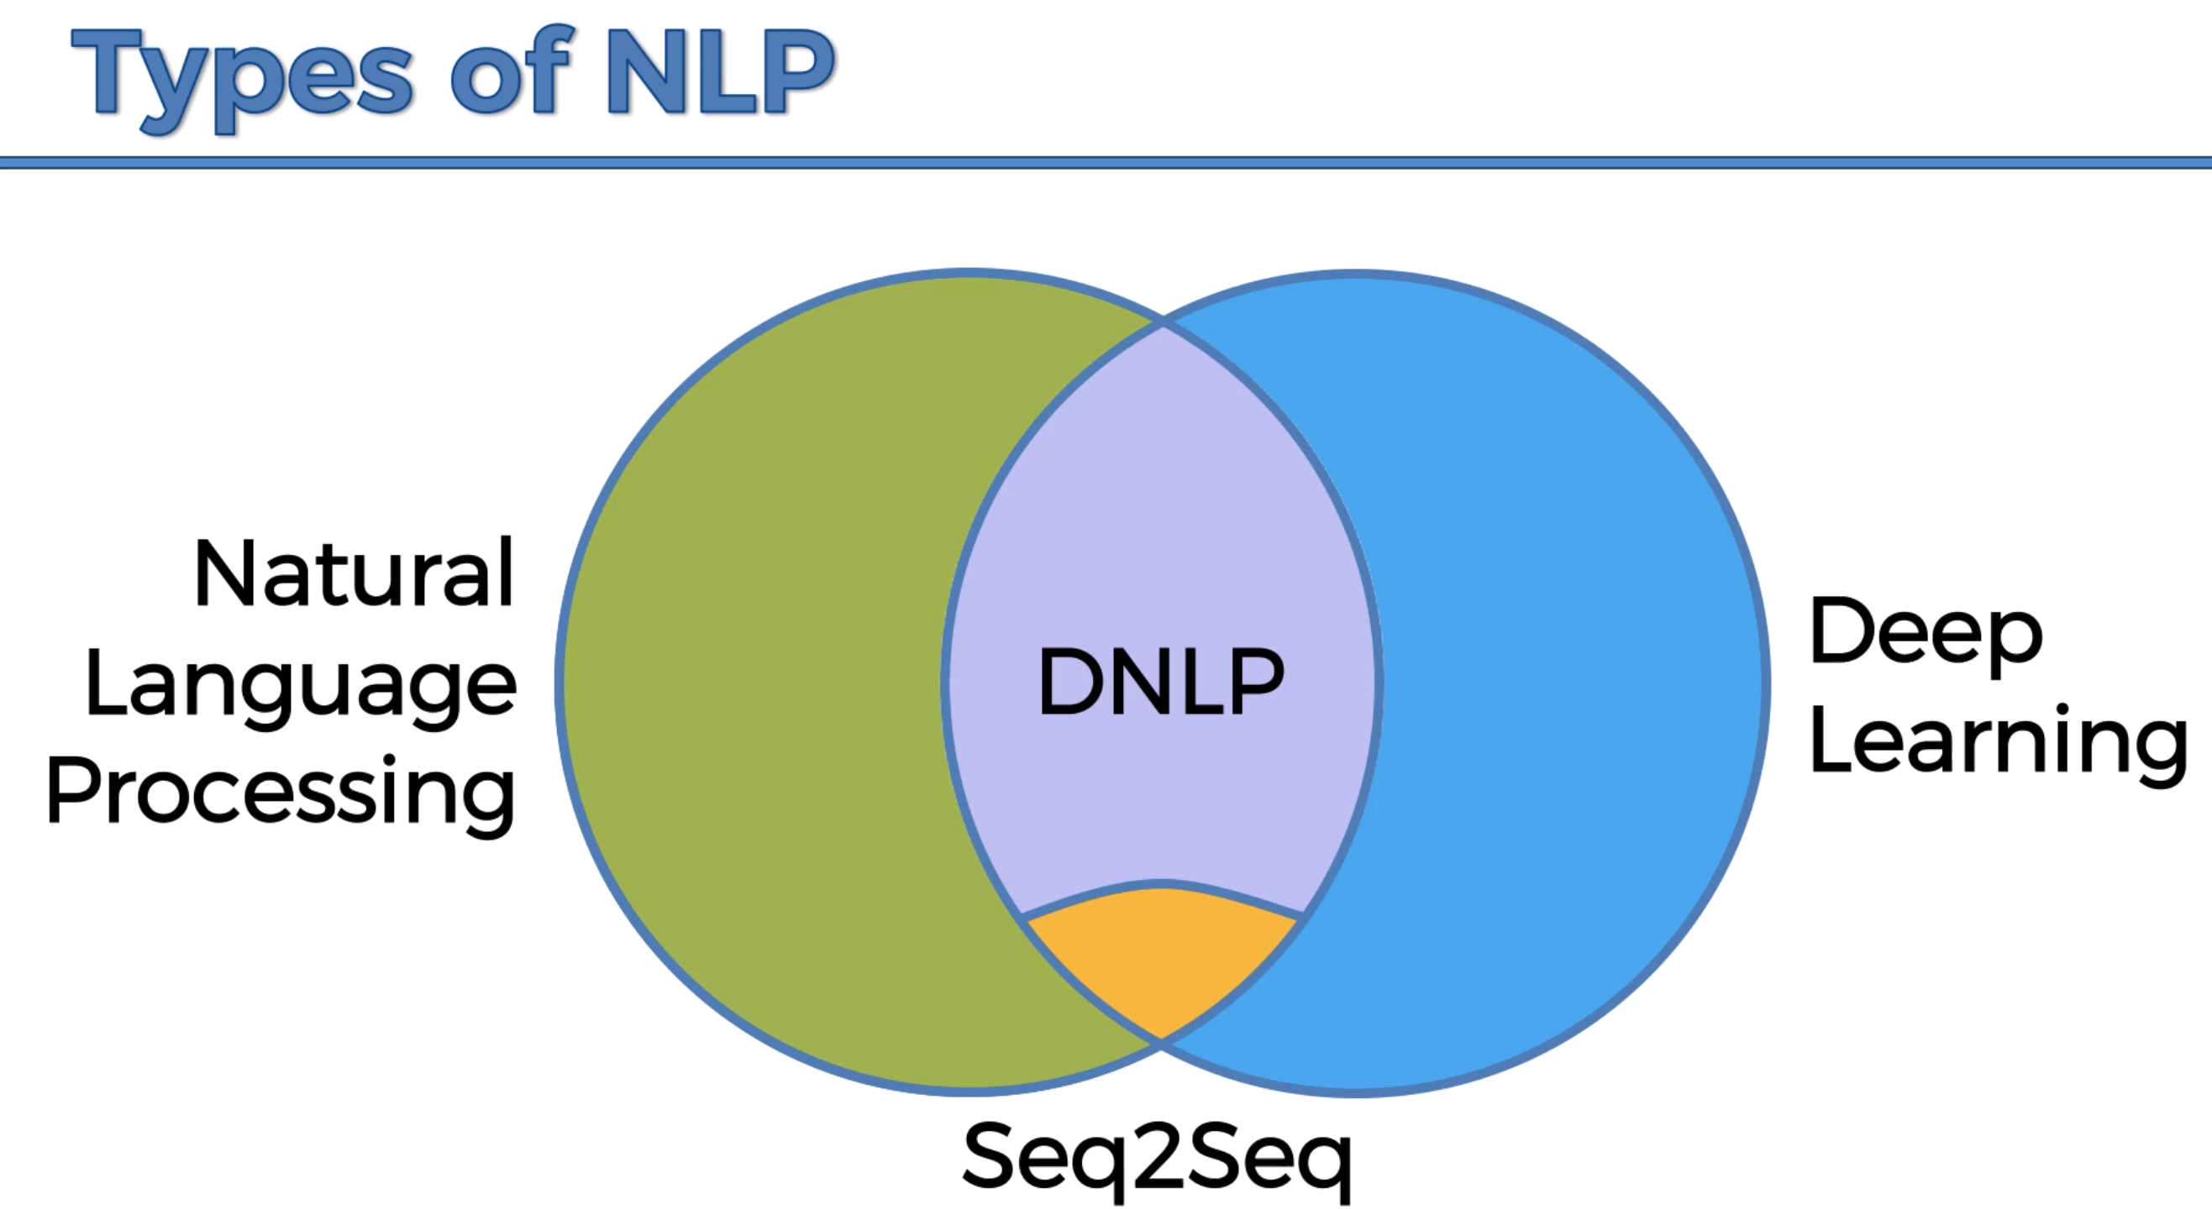

Seq2Seq – most cutting edge natural language processing models

Different examples of ChatBots.

Classical vs Deep Learning Models